**Spiceworks – Main page**

Scrap the same data for all products (Here it is 138 products in networking category in the image below)

Links for different product categories:

* [Networking](https://community.spiceworks.com/networking/product/reviews?selector_query=dell)
* [Storage](http://community.spiceworks.com/storage/product/reviews?utf8=%E2%9C%93&source=channel_search_bar&selector_query=dell)
* [Servers](•%09http:/community.spiceworks.com/hardware/server-storage/reviews?selector_query=dell)

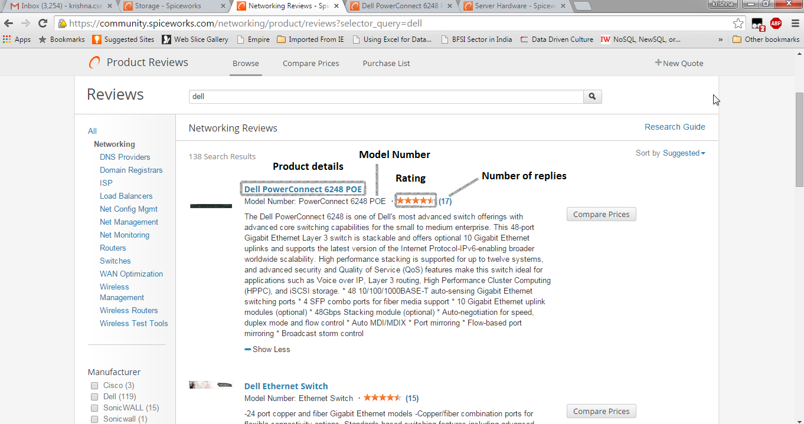

When you click on any of the products, you enter into product page where you need to scrap the data as per below.

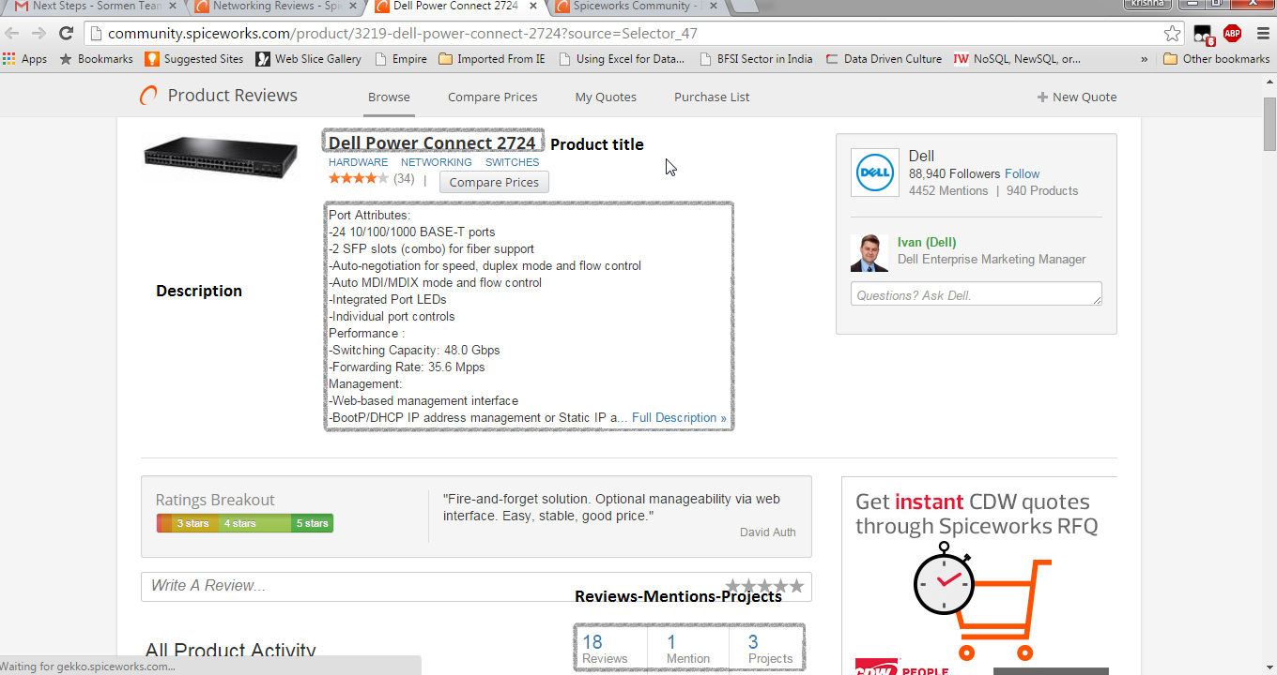

By default, the reviews, mentions and projects are mixed, you need to click on the reviews and mentions to capture specific details regarding them as below

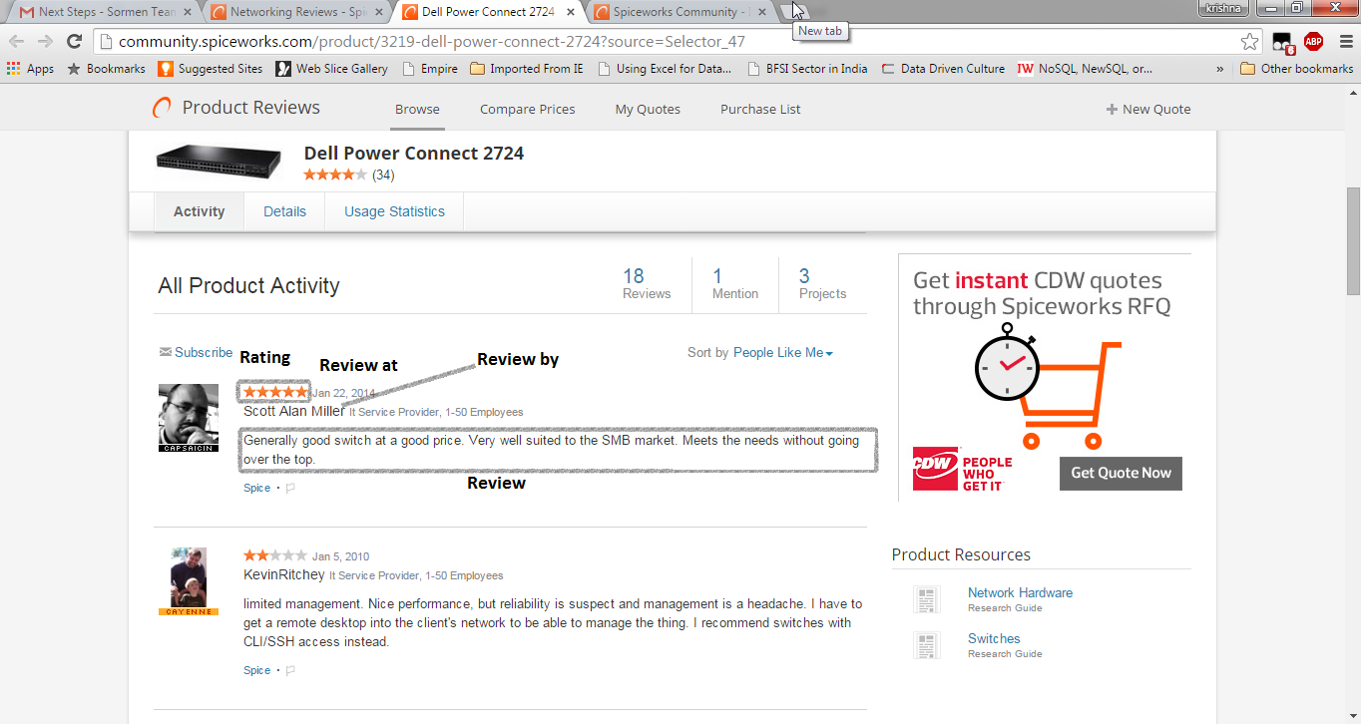

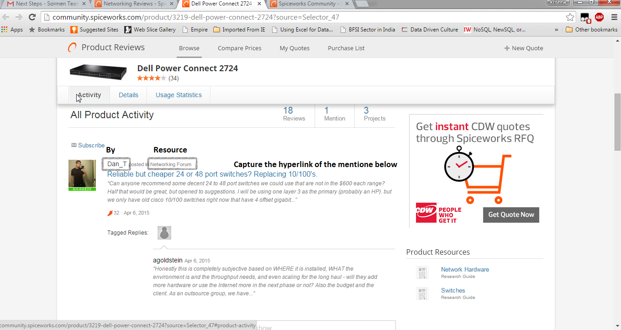

Mentions Page

Capture all the mentions (hyperlinks) of every product listed in the spice works.

Capture the following data from the mentions

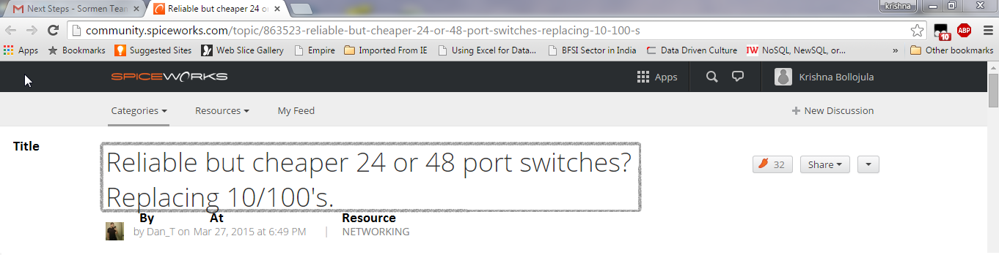

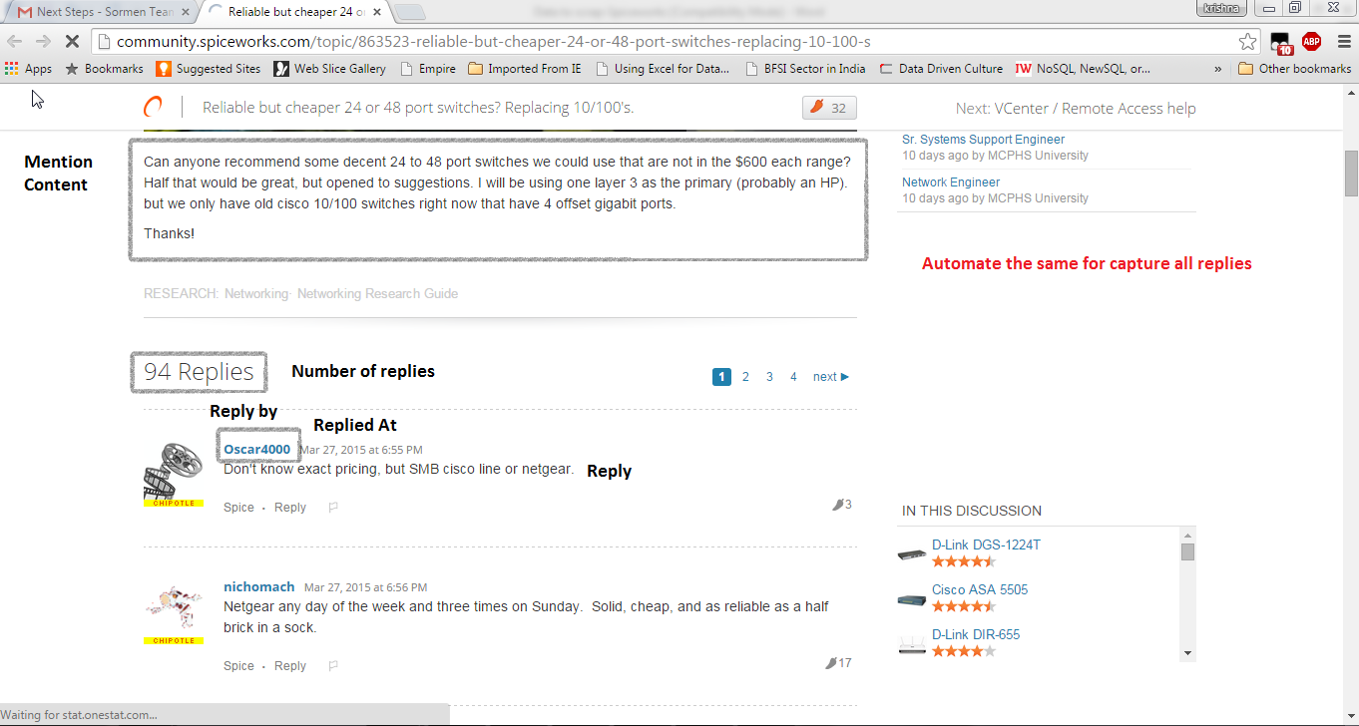

Please check the excel sheet for the reference while scraping the data.